Step 1: ER Diagram & Normalization Report

# Entities and Attributes

|  |  |
| --- | --- |
| Entity | Attributes |
| User | user_id (PK), name, email, role |
| Agent | agent_id (PK), name, department |
| Category | category_id (PK), category_name |
| Ticket | ticket_id (PK), title, description, status, created_at, user_id (FK), agent_id (FK), category_id (FK) |

# Relationships

- A User can raise many Tickets  
- An Agent can handle many Tickets  
- A Category can classify many Tickets  
- A Ticket belongs to one User, one Agent, and one Category

ER Diagram

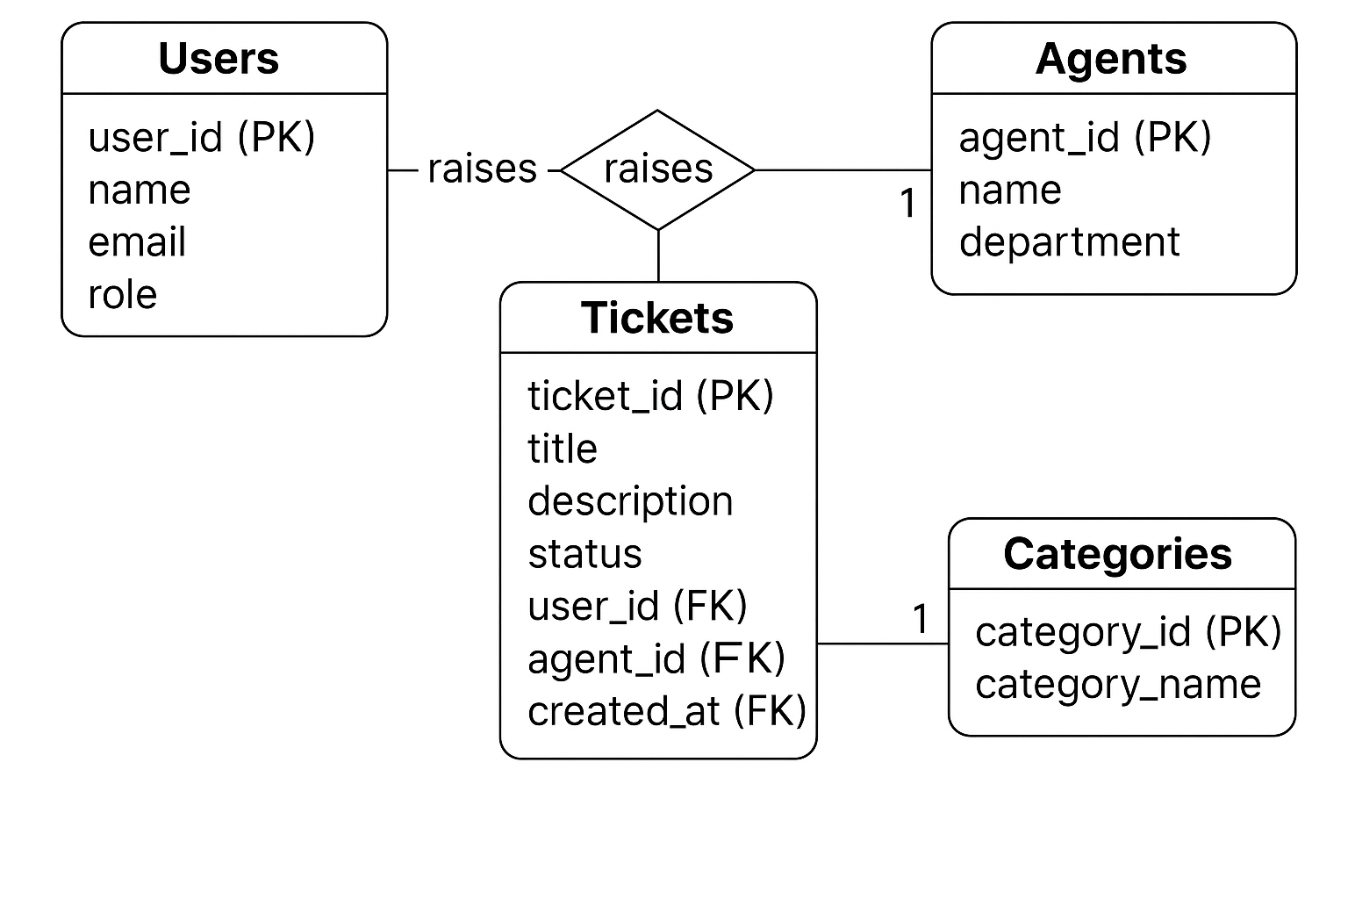

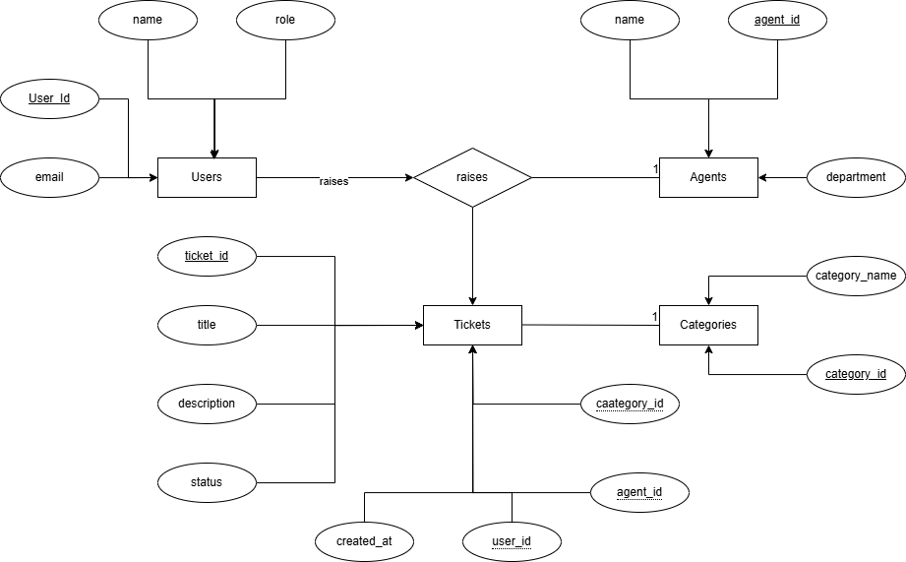

Normalization Report – Smart Service Desk

# 1. Unnormalized Form (UNF)

This is the initial unnormalized structure where multiple entities' data is stored in one table, resulting in redundancy and anomalies.

|  |  |  |  |  |  |  |  |  |  |  |  |  |
| --- | --- | --- | --- | --- | --- | --- | --- | --- | --- | --- | --- | --- |
| TicketID | Title | Description | Status | CreatedAt | UserID | UserName | Email | AgentID | AgentName | Department | CategoryID | CategoryName |
| 1 | Login Issue | Can't login | Open | 2025-06-10 10:00:00 | 101 | Karthik | karthik@domain.com | 201 | John | IT | 301 | Software Issue |
| 2 | Keyboard Fault | Keyboard not working | Open | 2025-06-10 11:00:00 | 102 | Sai | sai@domain.com | 202 | Alice | Hardware | 302 | Hardware Issue |
| 3 | Reset Issue | Forgot password | Closed | 2025-06-10 12:00:00 | 101 | Karthik | karthik@domain.com | 201 | John | IT | 301 | Software Issue |

# 2. First Normal Form (1NF)

In 1NF, we ensure each field contains atomic values and remove repeating groups. The table is already in 1NF as each attribute holds atomic values.

# 3. Second Normal Form (2NF)

In 2NF, partial dependencies are removed by dividing the data into logical tables.

## Users Table

|  |  |  |
| --- | --- | --- |
| UserID | Name | Email |
| 101 | Karthik | karthik@domain.com |
| 102 | Sai | sai@domain.com |

## Agents Table

|  |  |  |
| --- | --- | --- |
| AgentID | Name | Department |
| 201 | John | IT |
| 202 | Alice | Hardware |

## Categories Table

|  |  |
| --- | --- |
| CategoryID | CategoryName |
| 301 | Software Issue |
| 302 | Hardware Issue |

## Tickets Table

|  |  |  |  |  |  |  |  |
| --- | --- | --- | --- | --- | --- | --- | --- |
| TicketID | Title | Description | Status | CreatedAt | UserID | AgentID | CategoryID |
| 1 | Login Issue | Can't login | Open | 2025-06-10 10:00:00 | 101 | 201 | 301 |
| 2 | Keyboard Fault | Keyboard not working | Open | 2025-06-10 11:00:00 | 102 | 202 | 302 |
| 3 | Reset Issue | Forgot password | Closed | 2025-06-10 12:00:00 | 101 | 201 | 301 |

# 4. Third Normal Form (3NF)

No transitive dependencies exist. Each non-key attribute is only dependent on the primary key. The schema is now in 3NF.

# 5. Summary of Normalization Steps

|  |  |  |
| --- | --- | --- |
| Normal Form | Action Taken | Outcome |
| UNF | Combined entity data with redundancy | Inefficient and prone to anomalies |
| 1NF | Atomic values ensured, no repeating groups | Satisfies atomic structure |
| 2NF | Removed partial dependencies | Efficient, reduced redundancy |
| 3NF | Removed transitive dependencies | Fully normalized relational schema |